Craft in a Bag

St. Patrick’s Day Craft Shamrock Man

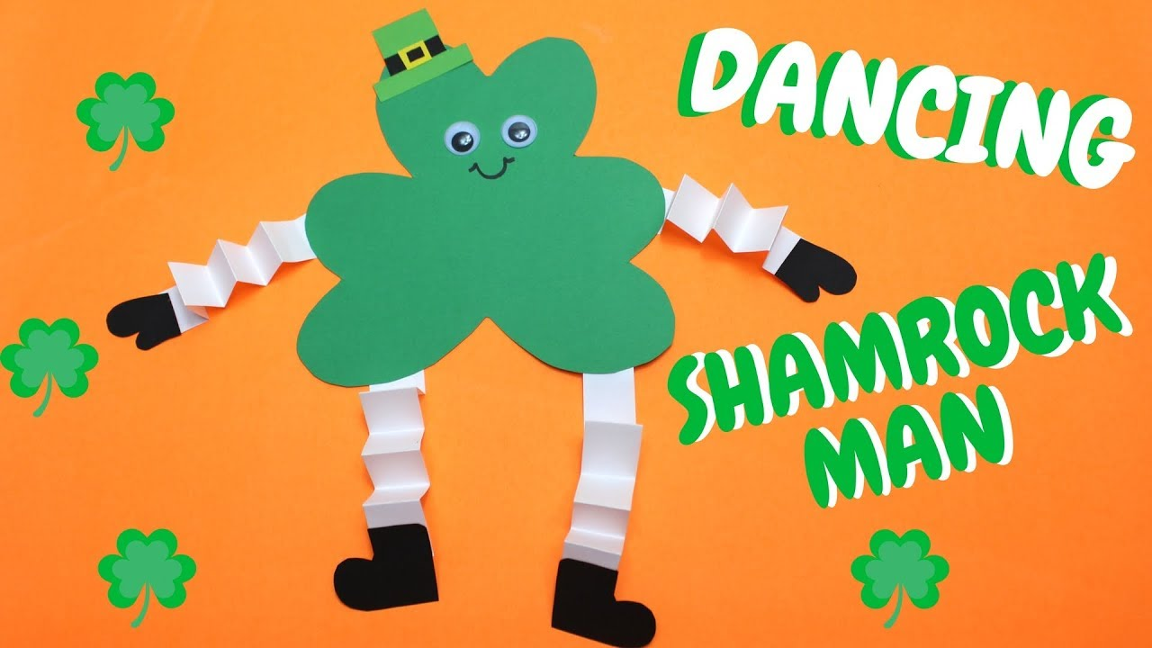

Pick up fun dancing Shamrock man craft kit at Prince Albert Public Library (Main Branch), and make it at home! Free Craft!

Kits available starting Sat, March 6th

First Come, First Serve

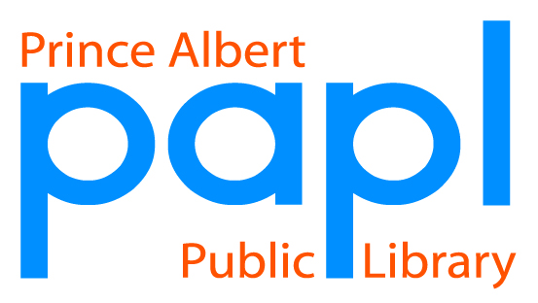(Curbside pickup also available)